Press Release

GC Luting Guide app:

Your cementing solution in less than five clicks!

There are numerous luting options available for the cementation of restorative materials but it is not easy for clinicians to keep track of them all. This is where the new GC Luting Guide app comes in. In less than five clicks, it recommends a match for every clinical challenge with its corresponding substrates.

In just a few clicks, the GC Luting Guide will recommend a luting material from the comprehensive GC portfolio to suit a variety of clinical situations and restorative materials. The first step is to select the clinical case. The app provides recommendations for restoration types such as crowns and bridges, inlays and onlays, veneers and pins. The second step is to select the material for the restoration. The GC Luting Guide covers all common materials such as composite, feldspathic ceramics, lithium disilicate, metal ceramics and hybrid ceramics. The next question is whether the restoration should be cemented as a short-term or long-term provisional or as a permanent restoration. Optional parameters are high or low retention and a dry or non-dry environment.

In less than five clicks, the app displays GC’s recommended luting solution for the particular clinical situation, providing the clinician with the name of the product and its clinical step-by-step. Additionally, these luting cements are rated on a scale of one to five on the various parameters: retention, aesthetics, ease-of-use, moisture tolerance and also price. This helps clinicians to select the right luting solution for their needs.

The app also gives the clinician a brief overview, using high-resolution images, of the step-by-step instructions for all recommended materials. These instructions are also appropriate for explaining the course of treatment to the patient.

So think about it: in less than five clicks, the GC Luting Guide provides a detailed overview of available luting solutions for almost every clinical situation. Apart from saving time in searching for the ideal luting solution, the app reassures clinicians that they are using the right luting solution for their particular case.

The GC Luting Guide is available free of charge from the App Store and Google Play or at http://luting.gceurope.com/navigationguide.

Apple Luting Guide App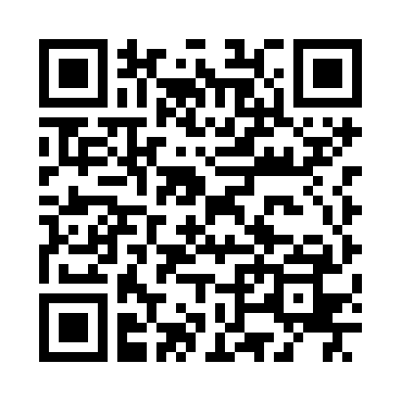 | Android Luting Guide App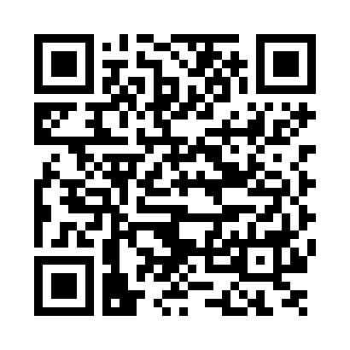

GC Europe N.V.  Interleuvenlaan 33  3001 Leuven  Fon +32.16.74.10.00  Fax +32.16.74.11.99  www.gceurope.com  marketing@gceurope.com  Press contact:  Dr. Kaschny PR GmbH  Kapersburgweg 5  61350 Bad Homburg  Fon +49.6172.68.481.0  Fax +49.6172.68.040.20  gceurope@kaschnypr.de  www.kaschnypr.de | GC / IDS 2017 stand:  Hall: 11.2  Stand: N010-O029

