Press release

A new state-of-the-art production facility at GC Europe

Expansion of GC Europe marked with traditional Japanese groundbreaking ceremony

Leuven, Belgium - June 27, 2024. GC Europe has commenced construction on a cutting-edge production facility, marked by a traditional Japanese groundbreaking ceremony. The event, held in the presence of GC’s global management team and Takenaka, the construction company, anticipates project completion by the end of 2025. This new 4,200-square-meter facility will boost GC Europe's production and logistics capabilities.

The ceremony, known as "Ji Chin Sai," featured Shinto rituals to purify the land and ensure the project's success. Key rituals, including the Ji Chin no gi (Spading Ritual) and Tamagushi Hoten (Dedication of Green Branches), were performed by:

Mr. Makoto Nakao, Chairman, President, and CEO of GC Holding AG
Mr. Josef Richter, President and COO of GC Europe AG
Mr. Ludo Rits, Deputy General Manager of Takenaka Europe GmbH

The new three-story building will house manufacturing, assembly and warehousing areas, this way further increasing global ceramic, composite as well as digital material and equipment capabilities. Future plans include a direct connection to the existing logistics building to optimise workflow and efficiency.

This new facility reinforces GC Europe's commitment to growth and excellence in the dental industry. The Leuven site, central office of GC Europe's operations covering European, Middle Eastern and African markets for decades, includes various production, logistics, and training facilities.

Since the opening of its first office in Kortrijk, Belgium in 1972, GC Europe has expanded in the region through the decades with factories, offices, warehouses, and training centres. Today, it operates under a robust management system that upholds the highest industry standards.

About GC Europe
GC Europe is a leading provider of dental products and services, dedicated to improving oral health and quality of life through innovation and excellence. With a strong presence in Europe, the Middle East and Africa and a commitment to sustainability and community engagement, GC Europe continues to be at the forefront of dental innovation.

GC Europe N.V.
Interleuvenlaan 33
3001 Leuven
+32.16.74.10.00
https://www.gc.dental/europe
info.gce@gc.dental

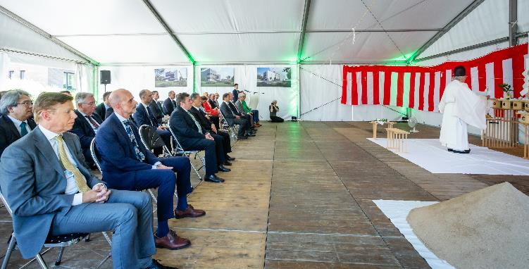
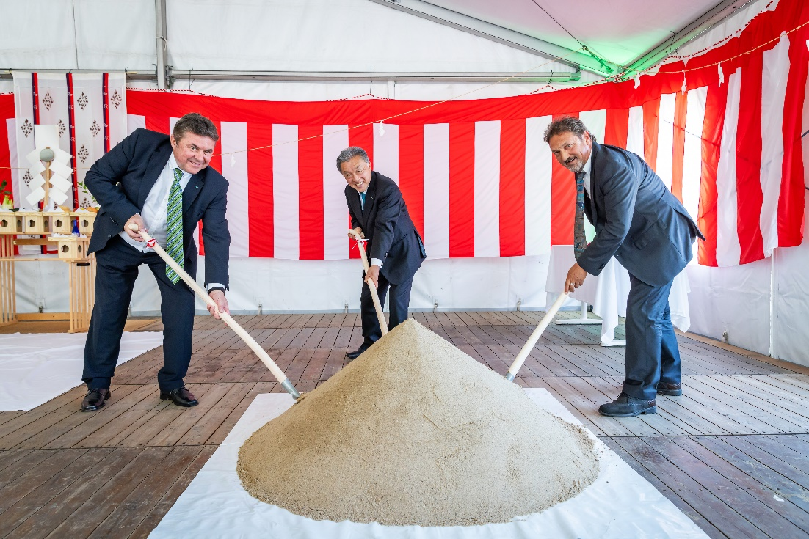
From left to right: Mr. Josef Richter, Mr. Makoto Nakao and Mr. Ludo Rits

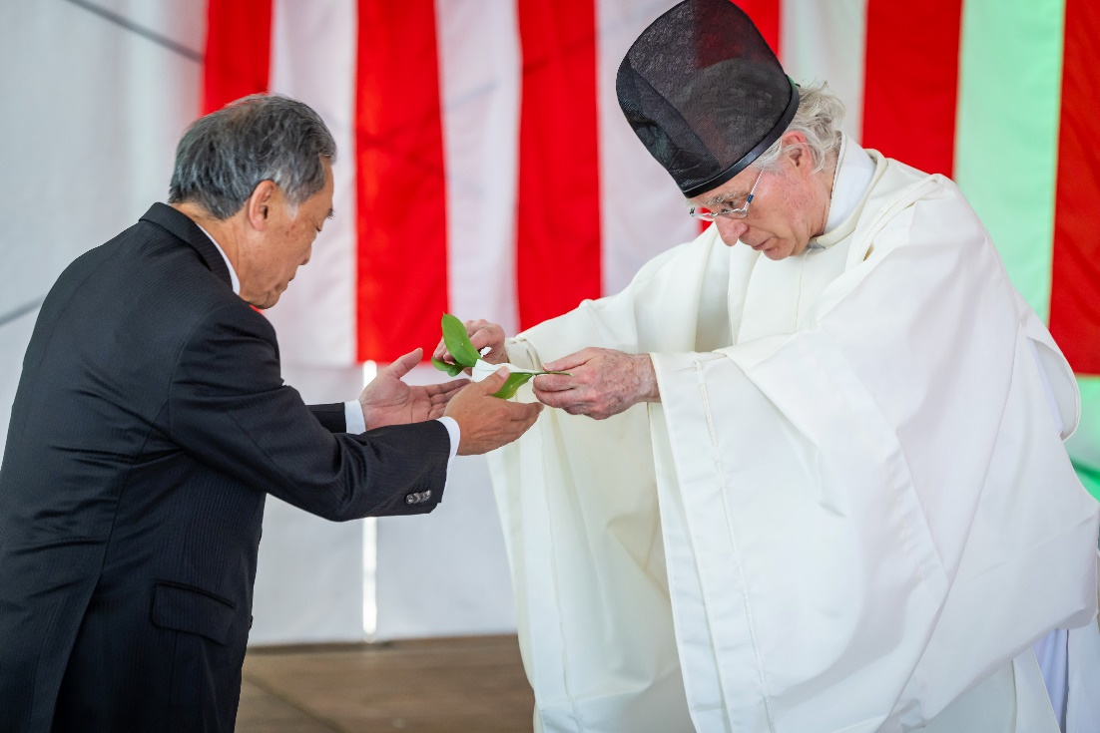
Mr. Makoto Nakao (left) and Shinto Master Drs. Paul de Leeuw (right)

