**Press release**

Opening of the reborn GC Corporate Centre

**New venues and art installations fostering innovation and GC’s core philosophy**

**GC Corporation has recently reopened its newly expanded GC Corporate Centre in Tokyo, emphasising innovation and fostering communication within the dental community. This renovation is part of the company’s broader strategy, which began in the early 21st century with the redevelopment of buildings in Osaka and Nagoya, followed by the structural upgrade of the former headquarters in Itabashi, and continued with a focus on its roots as a research and development company.**The new headquarters in Hongo, Bunkyo Ward, completed in 2011, serve as a hub for dental professionals and support the company’s mission to lead in dental care innovation. Since then, the centre has served as a communication base for disseminating information and has welcomed approximately 300,000 guests —mainly dental professionals— from around the world.

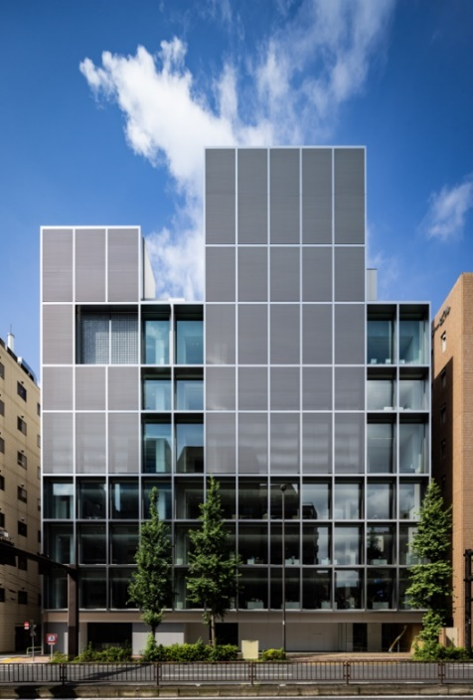

店の天井からぶら下がっているキッチン

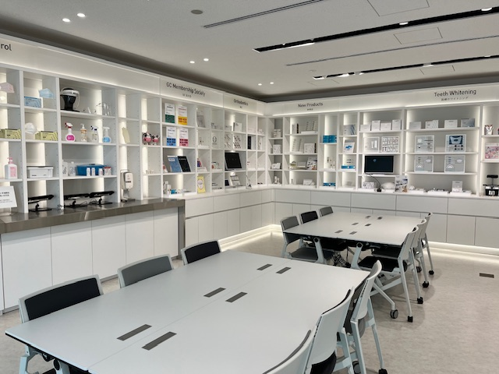

6F Showroom (Simulation Floor)

1F Dental Information Gallery

New CG Corporate Centre

The reborn GC Corporate Centre has been renovated and expanded, and includes a fully upgraded showroom, a Dental Information Gallery, and expanded office spaces that foster innovation. The showroom offers hands-on product experiences, simulating real clinical environments. The gallery aims to raise awareness of oral health among the general public and features educational displays on dental care across life stages.

In addition to these functional spaces, the centre integrates art installations by the digital art collective teamLab, whose works align with GC's core philosophy of SEMUI—thinking and acting from others' perspectives. These installations encourage boundaryless thinking, reflecting the company’s vision to transcend cultural and linguistic barriers. The artworks are intended to inspire both employees and visitors, strengthening GC’s values as it works towards its “Vision 2031: to become the leading dental company committed to realizing a healthy and long-living society.”

A new symbol of GC’s company philosophy SEMUI

MEGALITH©︎ by teamLab

GC Europe N.V.

Interleuvenlaan 33

3001 Leuven

+32.16.74.10.00

https://www.gc.dental/europe

[info.gce@gc.dental](mailto:info.gce@gc.dental)