**Press release**

**GC Holding AG strengthens Corporate Governance and announces new CEO**

**Lucerne, Switzerland – October 1st, 2024 – Chairman Nakao and the GC Holding Board of Directors announce the appointment of Dr. Per Falk as CEO effective October 1, 2024**.

This decision strengthens GC Corporate Governance by setting up GC Holding as GC group parent company and major shareholder. This builds on GC's proud history as an agile organization founded in 1921 in Japan and run by the Nakao family for over 100 years. In 1934, Kiyoshi Nakao first transformed the “GC Chemical Research Laboratory” organization into a corporate structure to cope with business transformation and ensure future growth. GC continued to grow into a global company under the leadership of President Toshio Nakao. The company broke new ground by launching the famous “Fuji” brand of glass ionomer in 1977, when Makoto Nakao was appointed Executive Director and then President in 1983. On October 1, 2024, Mrs. Ayako Nakao becomes a member of GC Holding's Board of Directors, continuing the Nakao family's century-old entrepreneurial spirit.

Dr. Falk's appointment comes at a pivotal time as GC celebrates its 103rd anniversary and looks ahead to the next century of innovation and growth. Dr Falk has been a member of GC's Board of Directors for two and a half years. His career spans 25 years in pharmaceutical industry and he joins GC from Ferring Pharmaceuticals, where he was President.

Makoto Nakao, Chairman of the Board of GC Holding AG, expressed his confidence in Dr. Falk’s leadership: "*It is very fortunate for the GC Group and its shareholders that Dr. Per Falk will take on the CEO responsibility. His professional experience and knowledge of GC business, combined with the trust of the Nakao family, place him in an ideal position to become CEO of the GC Group*”.

Per Falk commented “*I am very excited over the opportunity to lead GC in its next growth phase and am truly honored by the trust and confidence given to me with this appointment. I look forward to working closely with our Chairman Mr. Nakao and all our skilled and dedicated colleagues to grow GC’s position as a strong contributor in the global dental and oral health sector*."

Under the leadership of GC Holding AG, headquartered in Lucerne, Switzerland, and its Board of Directors, GC is focused on its future to further develop its legacy of excellence in dental care, create value for stakeholders and improve oral health.

**About GC Group** GC is a leading global company in dental care and oral health. With a presence in over 100 countries and more than 3500 associates (employees), GC is committed to providing best-quality products and solutions to dental professional and patients worldwide.

GC International AG

Zürichstrasse 31

6004 Luzern, Switzerland

Tel: +41 41 203 27 29

[info@gciag.com](mailto:info@gciag.com)

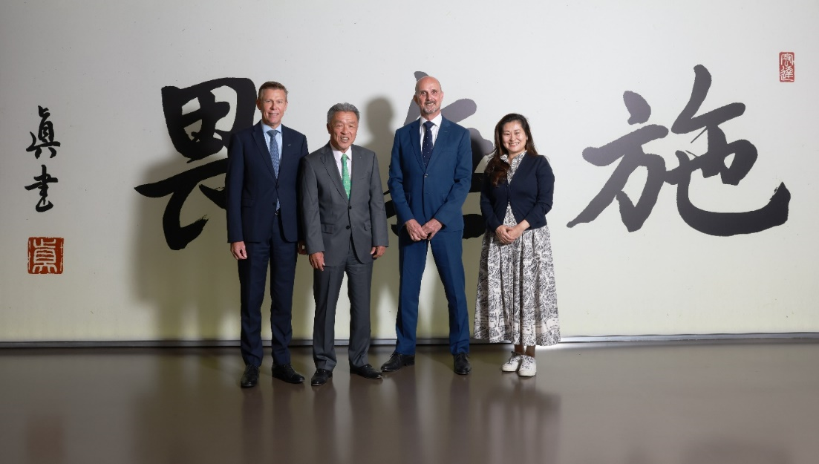

GC Holding AG, Members of the Board (from left to right): Dr. Roland Altwegg, Mr. Makoto Nakao, Dr. Per Falk, Mrs. Ayako Nakao